E – Commerce Portal - Dairy Products

Delicious Goat Milk

5-6-2018
Contents

Application Overview 2

1. Header 2

2. Footer 2

3. Home Page 2

4. About 2

5. Contact Us 2

6. Products 2

7. Cart Management 3

8. User 3

9. Admin 3

Sample Screenshots 4

Technologies 5

Development Phases & Cost 5

Bugs & Enhancements 6
Application Overview

- Header

  - Company Title & Logo

  - Basic Contact Information

  - Main Menu

  - Links to Pages on Social Networking Sites

  - Sign In / User Profile

- Footer

  - Contact Info

  - Link to About Us

  - User Testimonial Highlights

- Home Page

  - Header

  - Sliding Image Gallery

  - Order / Page View Statistics

  - Introduction

  - Featured Products & Link to Products Page

  - Sliding Links to Blogs

  - Footer

- About

  - About Us

  - Company Profile

  - Testimonials

- Contact Us

  - Contact Information

  - Enquiry Form

- Products

  - Grid View of all Products:

  - Product Image

  - Product Name

  - Product Cost

  - Product Ratings

  - Add to Cart

- Product Detailed View:

  - Product Image Gallery

  - Product Name

  - Product Description

  - Product Cost

  - Product Ratings

  - Add to Cart

  - Back to Grid View
- Cart Management

  - Update a Product Quantity

  - Delete a Product

  - Select Repetitive Order Option & Select Dates

  - View Summary

  - Checkout

- Register / Sign in (If not already Logged In) o Guest Checkout

o Enter / Choose Shipping Details o View Order Summary

o Submit Order - Mail/Download Invoice

- User

  - Register

  - Name

  - Email ID

  - Contact Number

  - Shipping Address

- Update Profile

  - Email ID

  - Contact Number

  - Shipping Address

- View Orders

  - Pending

  - History

- Update Order

  - Update Quantity

    - Update Shipping Address

  - Cancel Order

  - Review & Rating

- Admin

  - View Orders

    - Pending / History

  - By Product, Customer

  - Order Details

- Manage Products

  - Add Product
    - Product Name

    - Product Description

    - Product Cost

    - Product Images

    - Stock Option: Always show in stock / show out of stock when order exceeds inventory

    - Inventory Quantity

- View Products
  - Grid View of all Products

    - Product Name
• Product Image

• Product Cost
• Open Order Quantity
• Inventory Quantity
• Total Order Count
• Delete Product Option
• Update Inventory

Sample Screenshots
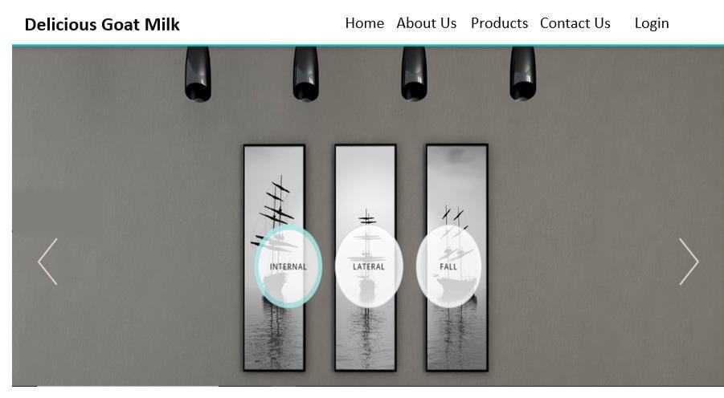

Figure 1 : Home Page
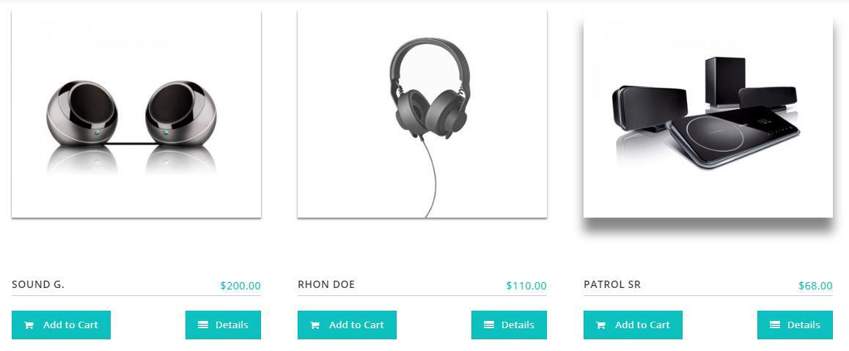

Figure 2 : Products Page

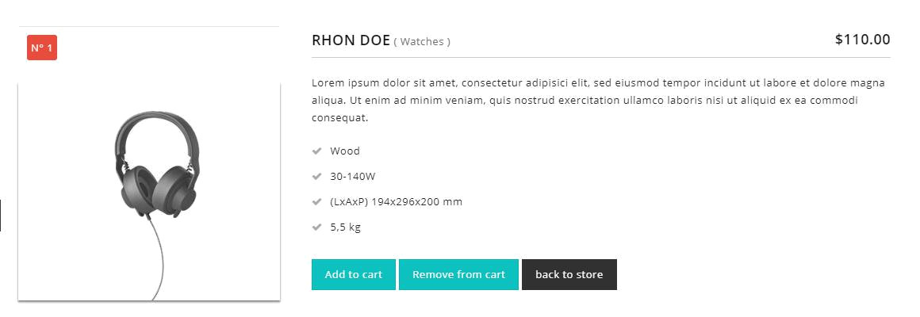

Figure 3 : Product Details
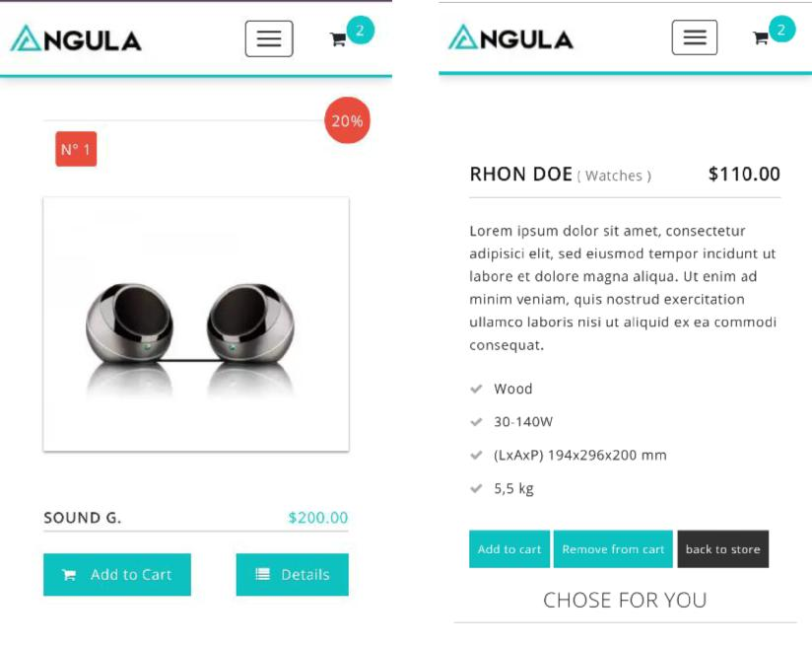

Figure 4 : Mobile View

Technologies

- Database: Firebase

- Scripting and Interface: HTML, CSS, JQuery, Angular JS

The website layout will be mobile responsive. It will yield optimal viewing experiences on hand-held mobile devices as well as desktop PC.

Bugs & Enhancements

- Bug fixes are Included

- Any further enhancements required will be charged as per the effort

